Rooms Info

THE NAUGHTY LIST (60 min.)

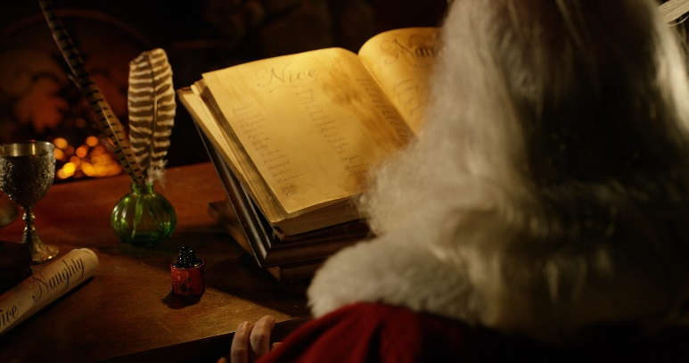

It’s beginning to look a lot like Christmas, and Santa has arrived in town to prepare gifts for all the Nice people. Unfortunately, this year you’re more than sure you’ve made his Naughty list and won’t be receiving anything. Unless…

You have strong intel that he checked in at the Moxy Hotel in Bucharest, and his Naughty and Nice list is carefully guarded in his room. You have 60 minutes to get to the list and figure out how to change it in order to save Your Christmas!  
Gather your team, plan your visit to the hotel and try to redeem yourselves!

P.S. Ace our secret mission within the game and you can be the winner of our Christmas Gift Box!

*Game available only during November 27th and December 6th  
**Available Romanian and English  
***Game takes place at the Moxy Hotel  
***Teams of 2 to 6/7 people

**** **60 RON** **for the game** (+40 RON/ person)

A HOLLYWOOD MURDER MISTERY (60 min.)



Foul play, scandal and bewilderment in old, glamorous Hollywood, when the star of the latest MGM Studios production vanishes without a trace.  
As lead private investigators from the top detective agency in Los Angeles, you’ve been called in by the movie’s producer to investigate the case and find the missing actress.  
Embark on a glamorous, intriguing adventure that will keep you on your toes and use your wit, flair and deductive skills to solve this mystery!

* Available only in English  
** For an optimal experience we recommend teams of 2-3 people  
*** Min. age 13 years. All children must be accompanied by at least one adult to be allowed access

**** **60 RON** **for the game** (+40 RON/ person)

HAUNTED HOTEL (60 min.)

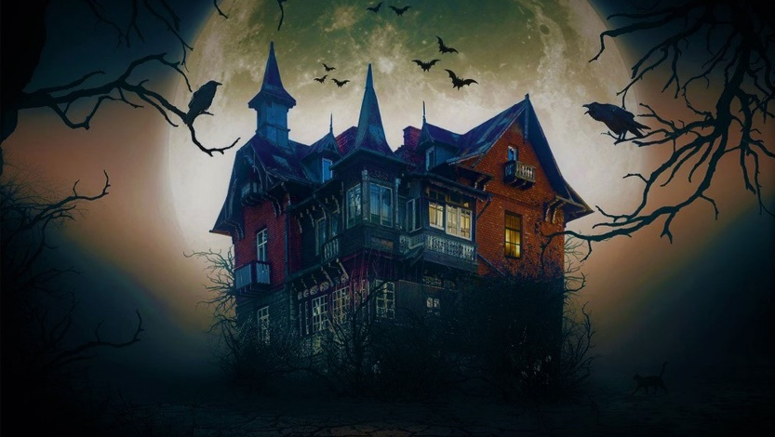

It’s Halloween and you’re on your way to a party when your car breaks down in the middle of the road. There’s no phone signal, no houses nearby and no help in sight…Except for a flickering light in the distance.  
Having no other choice, you decide to abandon your car and head for the lights. You’re relieved to see you’ve reached a small, isolated hotel. Surely someone in there can help you.  
The lobby looks warm and welcoming, but no one seems to be here. It’s suddenly getting very cold and an overwhelming feeling of unease sets in…  
Something is off about this place, you need to get out fast!

* Available only in English

** Min. 2, max. 4 people  
*** Min. age 13 years. All children must be accompanied by at least one adult to be allowed access

**** **90 RON** **for the game** (+40 RON/ person)

NOT ANOTHER VAMPIRE STORY (60 min.)

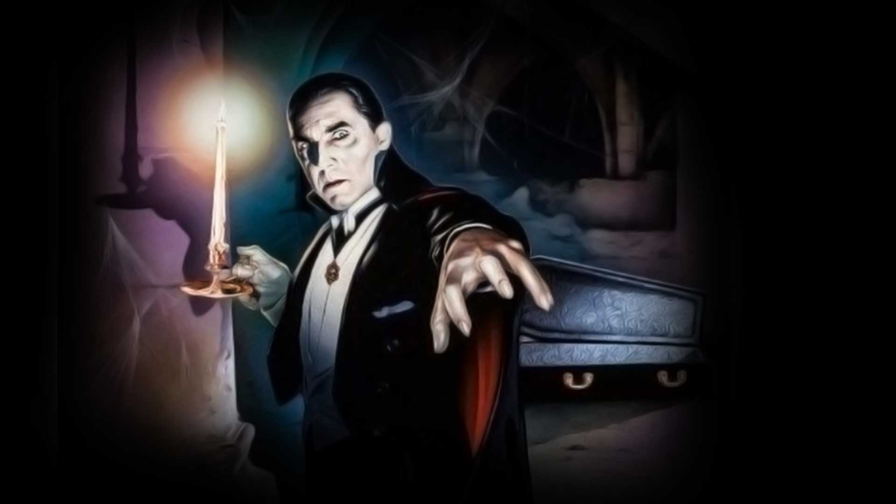

Transylvania, Dracula, Nosferatu… Forget everything you know about the classic tales of the undead and venture in the world of the most unconventional vampire! Vlad, the only “living” descendant of the famous Intuneceanu family needs your help to recover a prized object from his parents’ castle. You have one hour to face the dangers that await you and to escape with the mysterious object.

But Beware! This is NOT ANOTHER VAMPIRE STORY…

* Available in Romanian and English  
** Min. 2, max. 6 people

*** Min. age 18 years

**** **80 RON** **for the game** (+40 RON/ person)

PROHIBITION – AL CAPONE’S SPEAKEASY (60 min.)

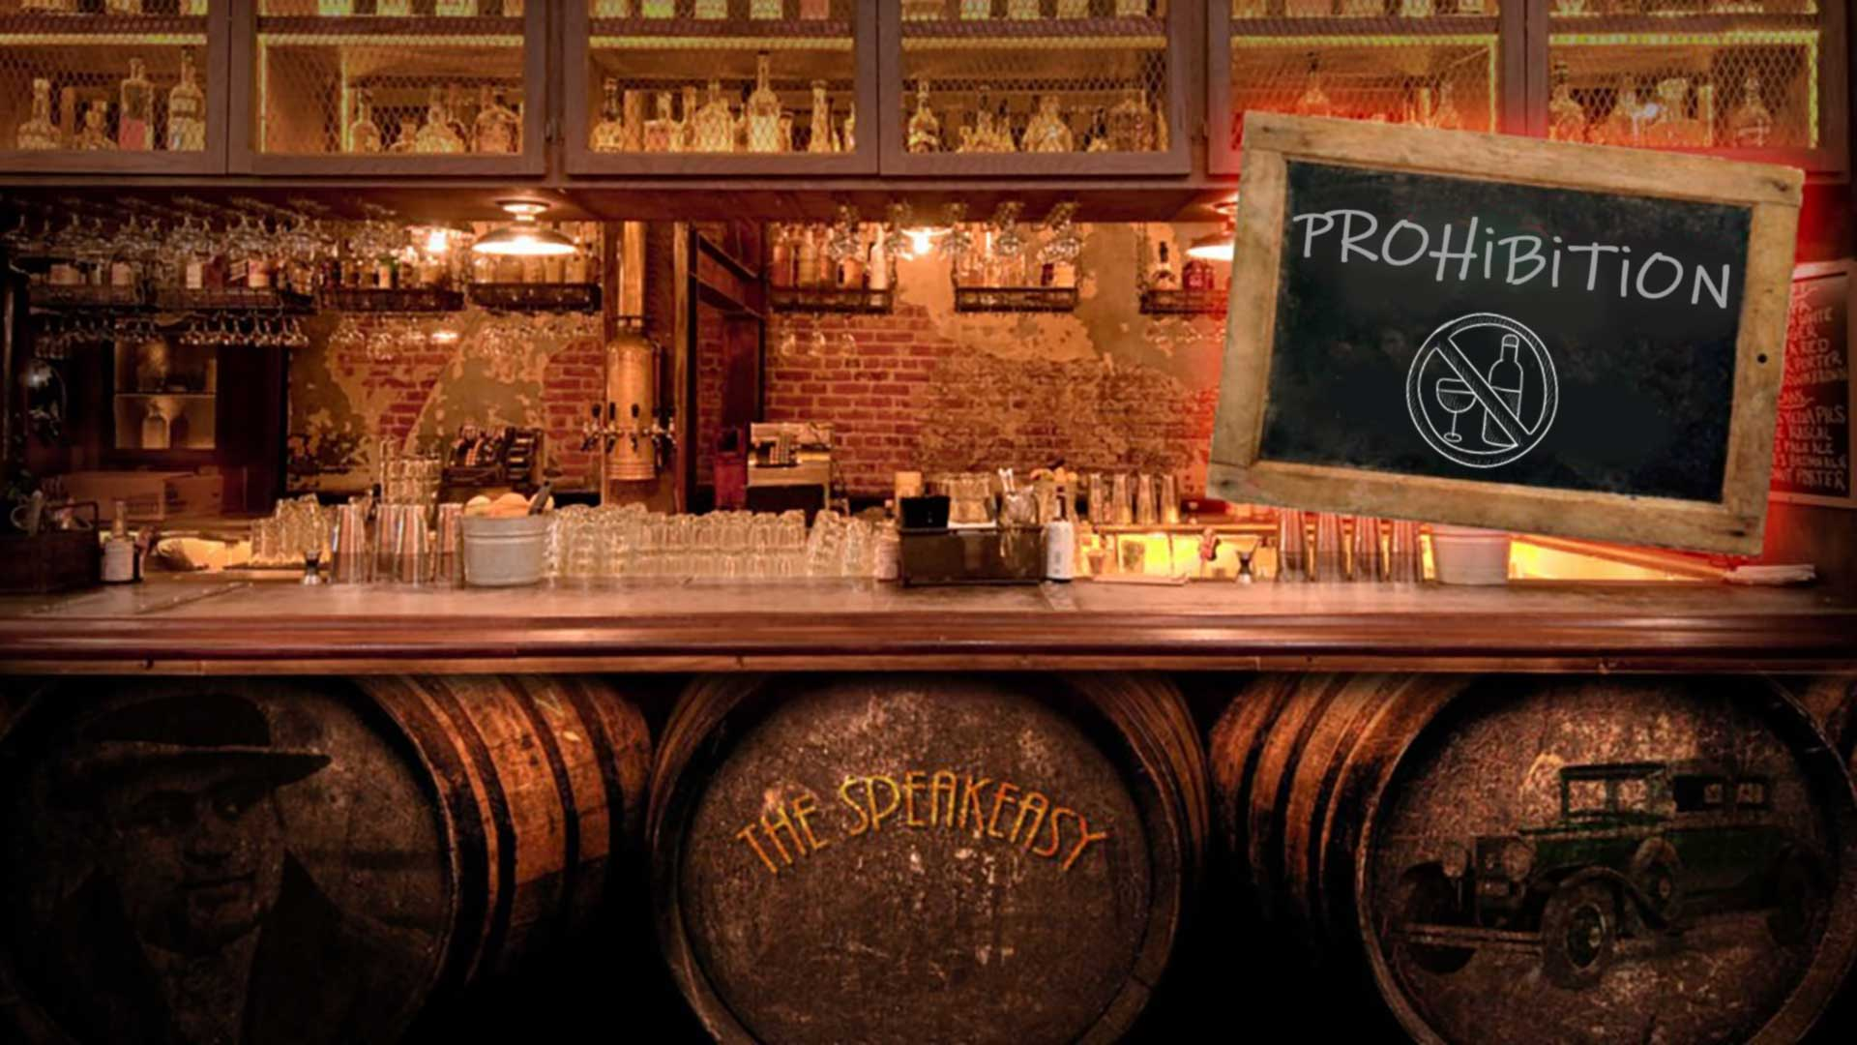

Go back in time to “The Roaring 20’s”, across the ocean, in the capital city of the Mafia and infiltrate Al Capone’s gang.  
To succeed, you must look like them, speak like them, act like them. Accomplish your mission and you’ll make it out alive. Fail and you’ll face some… permanent consequences.

* Available only in English

** Min. 2, max. 5 people  
*** Min. age 13 years. All children must be accompanied by at least one adult to be allowed access

**** **80 RON** **for the game** (+40 RON/ person)

SECRET SOCIETY (60 min.)

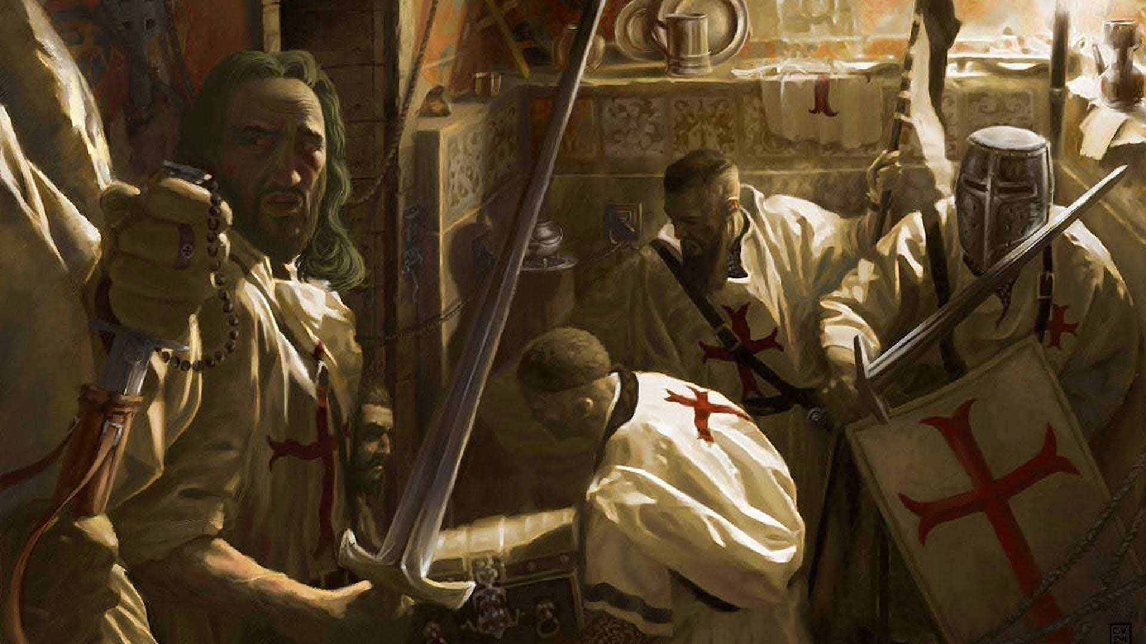

You awake in an unfamiliar place, resembling an old, medieval castle. You are surrounded by mysterious objects and symbols and the door behind you shuts with a loud noise, leaving you trapped.  
Looking for a way out, you stumble upon a letter addressed to you…  
It seems you are locked in the chambers of a powerful secret society and your only chance to escape is successfully passing the Initiation Trial. You have 60 minutes to summon the cult’s High Priest and convince him you are worthy of his assembly.

* Available in Romanian and English

** Min. 2, max. 6 people

*** **60 RON** **for the game** (+40 RON/ person)

CHALLENGE ROOMS – CAN YPU GET AWAY WITH MURDER? (90 min.)

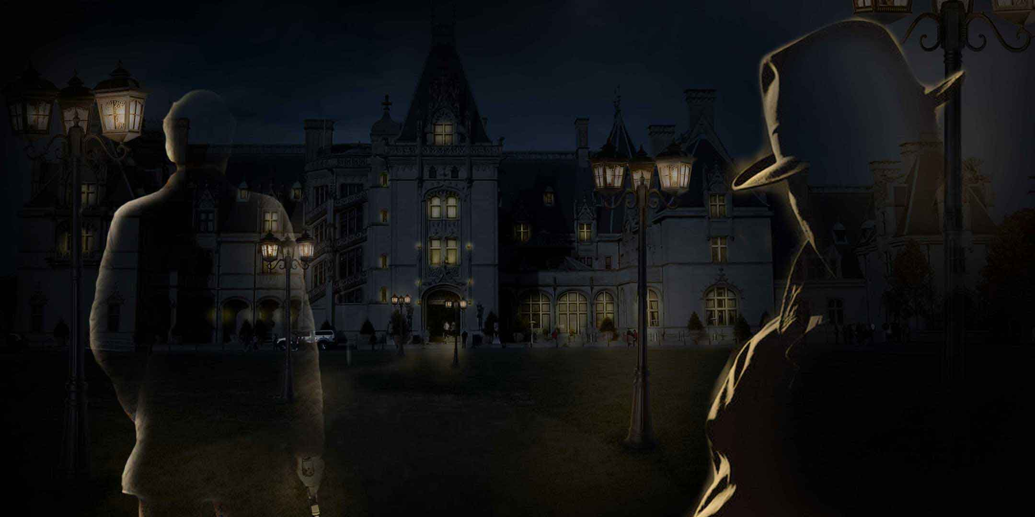

You are a highly skilled hitman commissioned to assassinate billionaire William Eldridge. You manage to infiltrate a party thrown in his honor, hoping this will prove to be the perfect opportunity to accomplish your mission.  
Your main goal is to procure a weapon, eliminate the target, dispose of the body properly and ultimately manage to get away, leaving no evidence that can be traced back to you.  
You have 90 minutes, but so does your fiercest competitor.  
Will you be able to complete your mission as well as dodge your opponent’s efforts to slow you down?

* Available in English and Romanian  
** Min. 4, max. 16 people

*** Min. age 17 years  
**** Two rooms and a common area, competition game

***** 17**0 RON** **for the game** (+40 RON/ person)

CHALLENGE ROOMS – THE DETECTIVE (90 min.)

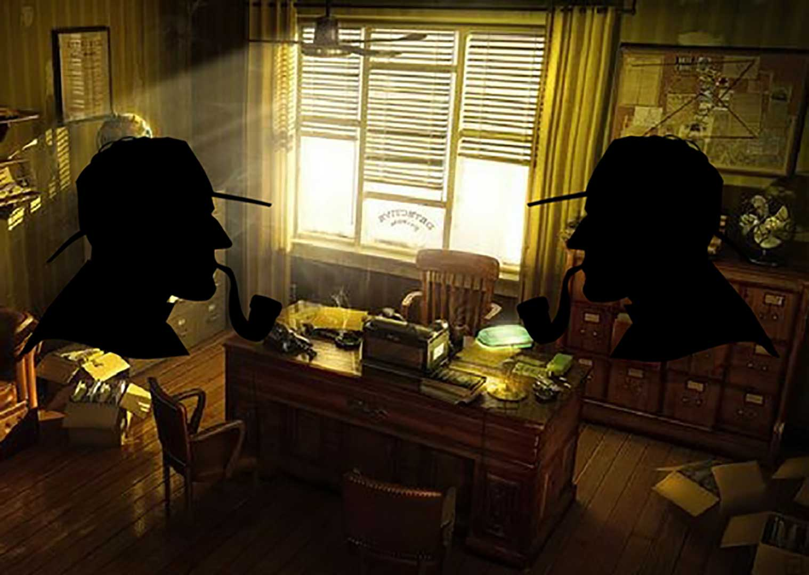

Two famous detective agencies challenge each other in solving the most difficult case in the history of Scotland Yard. Who will manage to solve the mystery behind millionaire’s Eldridge disappearance? Who will uncover the clues and eventually get the reward?  
The Detectives game is a perfect choice for children bookings and anniversary parties. Each player experiences the same dynamic, interactive and challenging adventure.

To book this game, please contact us at [office@thecodex.ro](mailto:office@thecodex.ro)

* Available in English and Romanian

** Min. 10, max. 18 people

*** Max. age 16 years  
**** Two rooms and a common area, competition game

***** 17**0 RON** **for the game** (+40 RON/ person)

Example for a group of 4 persons playing Secret Society: 60 RON + (4 pers. x 40 RON) = 220 RON (this is not for the database, it will be hard coded, it is only to understand costs, for more info go to [www.thecodex.ro](http://www.thecodex.ro) or ask Mary – which I did)